Task 3 — FairScope: Jurisdiction-Aware Fair Lending Compliance Tool
Option B — Architecture Design

1. System Overview
FairScope is a jurisdiction-aware fair lending compliance tool created for HSBC’s US and UK retail lending businesses. The tool monitors whether credit decisions are fair among different customer groups and produces outputs that match the relevant jurisdiction.
The reason this tool is needed is that fair lending does not mean exactly the same thing in the US and UK. In the US, the relevant rules include Regulation B and fair-lending expectations. In the UK, the focus is more on the Equality Act 2010, FCA Consumer Duty, and senior management accountability. The same credit model may make the same decision, but the compliance questions surrounding that decision differ depending on where it occurs.
FairScope is designed to separate regulatory logic from analytical logic. This means the tool can use the same credit application data, but apply different checks and generate different outputs depending on the jurisdiction.
Diagram reference: The overall system flow is shown in Diagram 1: FairScope Data Movement and Decision Points.
2. Architecture: Data Flows and Decision Points
Diagram 1: FairScope Data Movement and Decision Points.
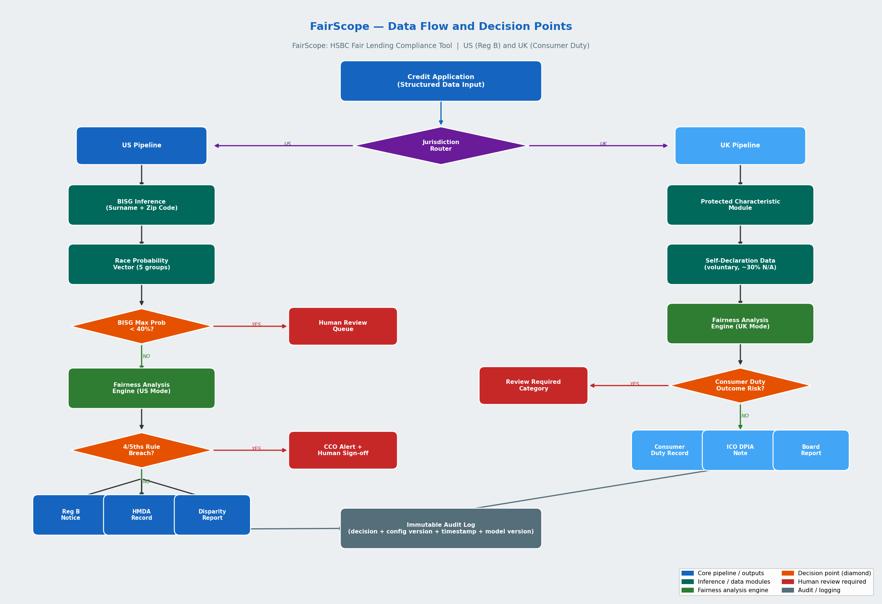
2.1 Input Layer
FairScope receives credit applications as structured records.
For US applications, the fields include:
- applicant surname;
- zip code;
- FICO score;
- debt-to-income ratio;
- loan purpose;
- loan amount;
- state.
For UK applications, the fields include:
- postcode;
- Experian credit score;
- debt-to-income ratio;
- loan purpose;
- optional self-declared protected characteristics.
FairScope does not change the existing application data. It works in read-only mode. It only writes to the audit log and output record store.
In Diagram 1, this is represented by the left-side input blocks for US Credit Application Data and UK Credit Application Data.
2.2 Jurisdiction Router
The first decision point is the jurisdiction router. This decides whether the application should go through the US or UK pipeline.
In a real bank, this would come from the originating branch or system. FairScope checks the jurisdiction flag against its configuration store. If the jurisdiction is missing or not recognized, the application is sent to a human exception queue. It is not processed using a default setting.
This is important because an incorrect jurisdiction setting can cause serious problems. For example, if a UK application is routed into the US pipeline, the system may run BISG race inference on a UK applicant. That could raise UK GDPR concerns about special-category data, because race and ethnic origin data require stronger legal safeguards. So the router acts as the first control.
In Diagram 1, this is the first decision box after the data input layer.
2.3 US Pipeline
For US applications, FairScope uses a BISG module where appropriate.
BISG stands for Bayesian Improved Surname Geocoding. It uses the applicant’s surname and zip code to estimate a probability vector for race or ethnicity. For example, it may estimate probabilities among White, Black, Hispanic, Asian, and Other groups.
This estimate is used only for aggregate fairness monitoring. It is not used to make the individual credit decision.
If the BISG result is weak, the case is flagged. For example, if the highest probability is below 40%, FairScope treats it as inconclusive and sends it for human review. This is a data-quality gate, not a loan denial.
In US mode, the fairness engine calculates approval rates by BISG-estimated group and checks the four-fifths ratio. The four-fifths rule is used here as an internal screening heuristic, not as a final legal conclusion. After the April 2026 Regulation B final rule, ECOA disparate-impact liability is no longer recognized by the CFPB in the same way, but FairScope still monitors group outcome differences for internal risk, state-law risk, litigation risk, and reputational risk.
If the four-fifths ratio falls below 0.80 for any group in the rolling quarterly cohort, the system alerts the CCO. The CCO must decide whether there is a business justification, whether the result is a data issue, or whether a model review is needed.
US outputs include:
- Regulation B adverse action notice;
- HMDA record for covered mortgage lending where applicable;
- separate internal disparity report based on BISG-estimated group outcomes.
BISG is used for internal fair-lending monitoring and should not be treated as a replacement for required HMDA demographic reporting.
In Diagram 1, this corresponds to the US Pipeline, including BISG inference, fairness analysis, human review trigger, and US regulatory outputs.
2.4 UK Pipeline
For UK applications, FairScope uses self-declared protected-characteristic data where it is voluntarily provided and lawfully collected.
The UK pipeline does not run BISG. This is intentional. BISG is based on US surname and geography data, so it may not work well for UK populations. Also, inferring ethnicity from name and postcode without proper consent could create UK GDPR issues. In the UK, the purpose is not to estimate race, but to monitor outcomes using properly collected equality data.
Self-declaration is voluntary. In the prototype, around 30% of applicants select “Prefer not to say” for ethnicity. This is a design assumption to reflect the fact that voluntary equality-monitoring data is often incomplete. Non-responses are excluded from protected-characteristic group analysis, but the non-response rate is reported clearly.
In UK mode, FairScope calculates approval rates, denial rates, and pricing trends among declared groups. It also classifies declined applications into Consumer Duty outcome categories, such as:
- fair outcome — financial risk;
- review required;
- good outcome.
UK outputs include:
- Consumer Duty outcome record
- data-protection note on special-category data treatment;
- Internal monitoring feed supporting the annual Consumer Duty board report.
The system can monitor outcomes quarterly, but the formal Consumer Duty board report is annual.
In Diagram 1, this corresponds to the UK Pipeline, including self-declared protected-characteristic handling, Consumer Duty outcome monitoring, and UK regulatory outputs.

2.5 Machine Learning Model Architecture
FairScope incorporates a Gradient Boosting Classifier (GBM) in both the US and UK pipelines. A GBM is a supervised learning model that builds an ensemble of decision trees sequentially, each tree correcting the residual errors of the previous. It was chosen for two reasons: it handles mixed feature types (ordinal credit scores, categorical loan purposes, encoded geographic codes) without manual scaling, and it supports exact SHAP values via TreeExplainer, which is important for regulatory auditability.
The ML model in FairScope does not make lending decisions. It is trained on historical application outcomes and used solely as the object of SHAP monitoring — to detect whether geographic variables are acting as proxies for protected characteristics. HSBC's underwriting model remains the decision-maker.
2.5.1 US Model Feature Set
Feature | Type | Regulatory note
fico_score | Continuous | Primary creditworthiness signal
dti_ratio | Continuous | Primary creditworthiness signal
log_loan_amount | Continuous | Loan size effect (log-transformed)
loan_purpose | Categorical (encoded) | Risk tier
zip_code | Categorical (encoded) | Potential race proxy — SHAP-monitored
state | Categorical (encoded) | Potential race proxy — SHAP-monitored

2.5.2 UK Model Feature Set
Feature | Type | Regulatory note
credit_score | Continuous | Primary creditworthiness signal
dti_ratio | Continuous | Primary creditworthiness signal
log_loan_amount | Continuous | Loan size effect (log-transformed)
loan_purpose | Categorical (encoded) | Risk tier
postcode_area | Categorical (encoded) | Potential ethnicity proxy — SHAP-monitored

Ethnicity data is deliberately excluded from both models. Including it would constitute direct discrimination under Regulation B (US) and the Equality Act 2010 (UK). SHAP is then used retrospectively to test whether any of the permitted features are correlated with protected characteristics. Both models are evaluated using AUC-ROC and five-fold cross-validation. A model version change triggers a new full SHAP proxy audit before the updated model enters production.

2.6 Explainability Framework: SHAP Integration
SHAP (SHapley Additive exPlanations) assigns each input feature a contribution value — called a Shapley value — representing the feature's marginal contribution to a specific prediction, averaged over all possible orderings of features. The Shapley values for all features sum to the difference between the model's prediction for that applicant and the dataset's mean prediction. The method is grounded in cooperative game theory and is the only attribution method that satisfies efficiency, symmetry, and consistency simultaneously.
FairScope uses shap.TreeExplainer, which computes exact (non-approximated) Shapley values for tree-based models. This matters for regulatory purposes: approximate methods introduce variance that makes it harder to defend a specific attribution in an audit. TreeExplainer gives a deterministic, reproducible explanation for every prediction.
2.6.1 Global Explanations
Global explanations summarise how much each feature influences the model across the entire portfolio. FairScope reports the mean absolute SHAP value per feature as a share of total importance. This share is compared to the proxy alert threshold defined in the active jurisdiction configuration (15% in both US and UK configs). If a geographic feature — zip code in the US pipeline or postcode area in the UK pipeline — exceeds this threshold, a proxy alert is raised and human review is required before the next quarterly compliance report.
2.6.2 Local Explanations
Local explanations decompose the model's prediction for a single applicant. FairScope uses SHAP waterfall charts to show, for each individual decision, which features pushed the model toward approval and which pushed it toward denial. These local explanations serve two downstream uses: generating the factual content for Regulation B adverse action notices (US), and populating Consumer Duty outcome records for declined applicants (UK). Raw SHAP values are not shown to applicants — they are translated into approved reason codes before being included in customer-facing documents.
2.6.3 Proxy Detection via Dependence Plots
A SHAP dependence plot shows, for a chosen feature, how that feature's SHAP value varies across applicants. If points coloured by BISG-estimated race (US) or self-declared ethnicity (UK) cluster systematically above or below SHAP = 0, this indicates that the geographic variable is amplifying the approval probability for some groups beyond what credit risk alone would predict. This is the operational definition of a proxy variable in FairScope's monitoring logic and is the trigger for the human review workflows described in Section 3.
2.6.4 Jurisdiction-Specific SHAP Responses
Signal | US Response (Regulation B) | UK Response (Consumer Duty)
Geographic feature SHAP share > 15% | BISG + four-fifths check triggered; CCO alert | Consumer Duty review flag; DPO notification
Individual denial explanation | Populates Reg B adverse action reason codes | Populates Consumer Duty outcome record
Model version change | New SHAP proxy audit required (Always Human) | New SHAP proxy audit required (Always Human)
Feature removed from model | SHAP proxy audit re-run on revised model | SHAP proxy audit re-run on revised model

Neither Regulation B nor Consumer Duty specifically mandates SHAP monitoring. FairScope includes it as a substance-over-documentation measure: both frameworks require firms to demonstrate that they understand how their models produce outcomes and that those outcomes are not systematically unfair. SHAP provides an earlier warning signal than aggregate outcome statistics alone, because proxy effects become visible in feature importance before they accumulate into a statistically significant four-fifths breach or Consumer Duty outcome pattern.

3. Human Judgement vs. Automation
Diagram 2: Human vs Automation Decision Matrix.
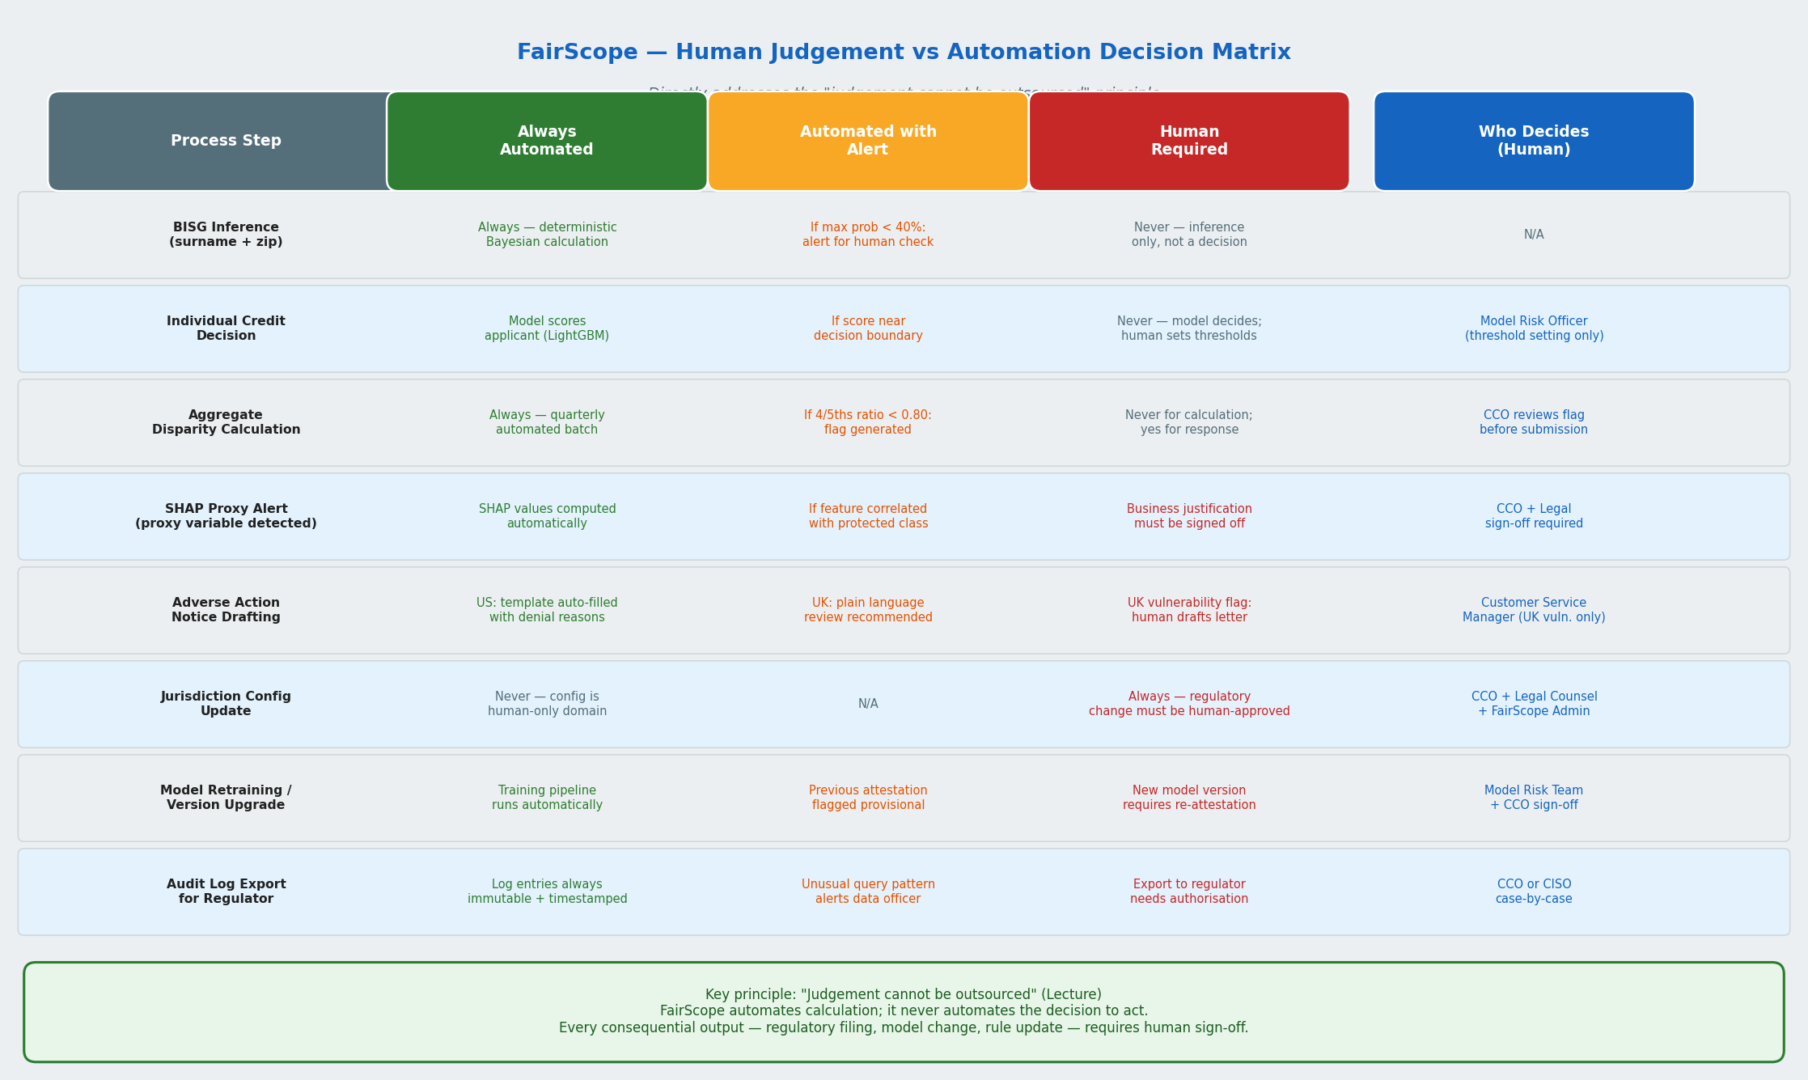
FairScope follows the principle that judgement cannot be outsourced completely to a tool. The tool can calculate, flag, and document, but humans still need to decide and take responsibility.
3.1 Always Automated
These parts are automated:
- BISG probability calculation;
- credit model score input from the bank’s model;
- aggregate disparity calculation;
- audit log creation;
- adverse action notice template population using approved reason codes.
These are shown in Diagram 2 under the Always Automated category.

3.2 Automated Alert, Human Action Required
These parts are flagged automatically, but a human must act:
- BISG inconclusive result;
- four-fifths ratio breach;
- SHAP proxy alert;
- Consumer Duty “review required” outcome.
For example, if SHAP shows that zip code is a major contributor and is strongly correlated with race, FairScope flags it. But a compliance officer and model risk manager must decide whether the variable has a valid business justification.
These cases are shown in Diagram 2 under the Automated Alert + Human Decision category.

3.3 Always Human
Some decisions are never automated:
- creating or updating jurisdiction configurations;
- activating a new credit model version;
- submitting HMDA or Consumer Duty reports;
- exporting audit records to regulators.
This matters because FairScope should not become the decision-maker. It should support accountable human judgement.
These decisions are shown in Diagram 2 under the Always Human category.

3.4 Substance Over Documentation
One important design choice is the SHAP proxy monitoring feature.
Neither Regulation B nor Consumer Duty specifically requires SHAP proxy testing. I included it because unfairness can enter a model through variables that look neutral, such as zip code or employer type. Without this feature, the tool might produce clean reports but still miss how discrimination is actually happening.
In Diagram 2, the SHAP proxy alert sits in the middle category because the system can detect the signal, but a human must decide whether the variable is justified.

4. Jurisdiction Rule Engine
Diagram 3: Jurisdiction Rule Engine and Versioned Config Store.
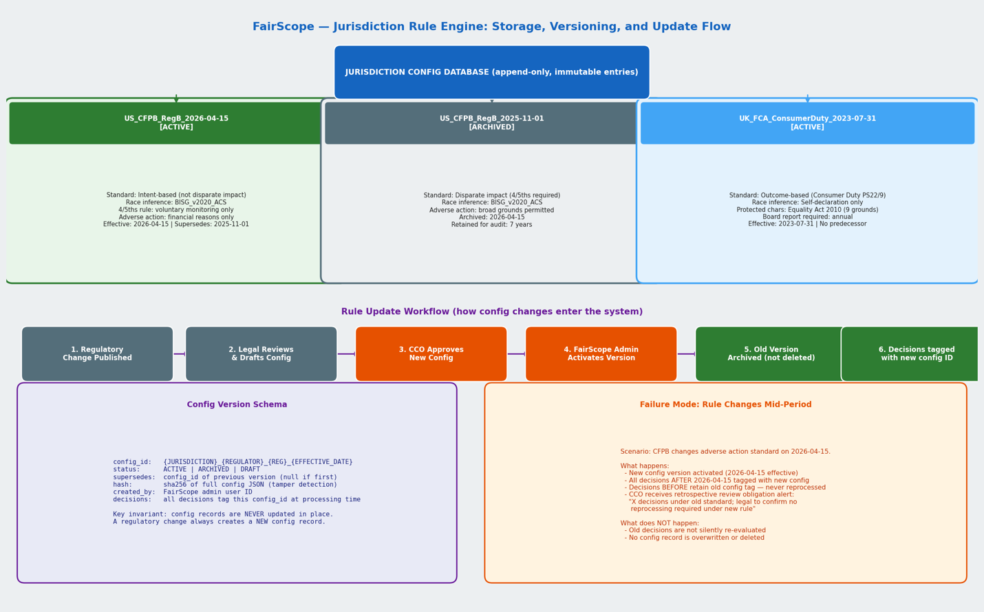
4.1 Design Principles
Regulations change over time, so FairScope does not hardcode rules directly into the analysis pipeline. Instead, it stores regulatory rules as versioned configuration records.
For example, the CFPB finalized amendments to Regulation B in April 2026, stating that ECOA does not authorize disparate-impact liability. For this prototype, I use 2026-04-15 as the internal configuration effective date.
A key design rule is that old configuration records are never overwritten. When a regulation changes, FairScope creates a new configuration version with a new effective date.
This helps create a proper audit trail. If a regulator later asks what rule was applied to a specific decision, the bank can show the exact configuration version.
In Diagram 3, this is represented by the separate Versioned Configuration Store, which feeds rules into the analysis engine without changing the underlying code.

4.2 Config Record Schema
Each configuration record includes:
- config_id
- status: ACTIVE, ARCHIVED, or DRAFT
- supersedes
- fairness_standard
- race_inference_method
- adverse_action_notice
- human_review_triggers
- hash
- created_by
- created_at
The hash helps detect tampering. The created_by and timestamp fields help show who made the configuration and when.
This schema is shown in Diagram 3 as the contents of each jurisdiction configuration record.

4.3 Config Versioning in Practice
When a regulatory change happens, the process is:
- A draft configuration is created.
- Legal and compliance teams review it.
- The CCO approves it.
- The new configuration is activated from the effective date.
- The old configuration is archived, not deleted.
- New applications are tagged with the new configuration.
- Old applications keep their original configuration tag.
This means FairScope can explain which rules were applied to which application at which time.
In Diagram 3, this is shown by the movement from Draft Config → Approved Config → Active Config → Archived Previous Config.

4.4 Jurisdiction Config Files
For this assignment, the active config files are:
- jurisdiction_config/US_CFPB_RegB_2026-04-15.json
- jurisdiction_config/UK_FCA_ConsumerDuty_2023-07-31.json
These are the configuration files that FairScope would load when the system starts.
They correspond to the two active jurisdiction branches shown in Diagram 3.

5. Failure Mode Analysis
5.1 Rule Changes Mid-Period
A rule may change in the middle of a reporting period. For example, if Regulation B changes during a quarter, some applications may have been processed under the old rule and some under the new rule.
FairScope handles this by tagging each application with the rule version used at the time. The CCO receives a split-cohort alert if one reporting cohort contains more than one regulatory configuration.
The report is not silently merged. It shows separate results for the pre-change and post-change periods.
If this control fails, the bank may apply the wrong legal standard and may need to reprocess or reissue outputs. The split-cohort alert is the safeguard.
From Diagram 3, this shows as the Rule Change Mid-Period → Split-Cohort Alert control path.

5.2 Model Drift
If HSBC retrains its credit model, the new model may behave differently. It may improve forecast precision but introduce a new proxy variable.
For example, mobile phone usage patterns may become important in the new model and may indirectly correlate with age or race in some locations.
FairScope checks the model registry for new model versions. When a new version is deployed, the old SHAP fairness attestation becomes provisional. FairScope then runs a new proxy audit before the model is fully approved.
FairScope does not automatically roll back the model. It only surfaces the risk. The model risk team and CCO make the final decision.
In Diagram 2, this seems as the Model Retraining → New SHAP Proxy Audit control path.

5.3 Conflicting Jurisdiction Requirements
A major conflict can arise around protected-characteristic data.
For example, UK equality monitoring may allow self-declared ethnicity data to be collected under proper controls. But US credit decisioning should not use race directly.
FairScope handles this through pipeline separation. The UK pipeline does not call the BISG service, and UK equality data does not flow into the US credit decision pipeline.
If data is accidentally routed to the wrong pipeline, FairScope blocks the transfer and alerts the data protection officer or compliance team.
In Diagram 1, this seems as the Jurisdiction Conflict → Pipeline Isolation + Data Protection Alert control path.

5.4 BISG Demographic Drift
BISG depends on surname and geography data. But neighbourhoods change over time.
FairScope runs a quarterly drift check comparing current ACS demographic data with the data used to calibrate the BISG module. If the population makeup of a zip code changes by more than five percentage points for any group, the zip code is flagged.
The system then alerts the CCO that BISG accuracy may be lower for that area. Until recalibration is done, BISG outputs for that zip code are treated as lower confidence.
In Diagram 2, this shows as the BISG Drift → Zip Code Recalibration Alert control path.

6. What FairScope Does Not Do
FairScope does not make lending decisions. It only monitors the decisions made by HSBC’s own underwriting system.
FairScope does not measure individual fairness. It mainly measures group-level outcomes and monitoring indicators. Whether a specific individual was treated fairly still requires human judgement.
FairScope does not cover all US state-level rules. It currently focuses on federal Regulation B. State-level requirements would need to be added later.
FairScope does not guarantee BISG accuracy. BISG is imperfect, especially for ambiguous surnames, mixed-heritage applicants, recent immigrants, and changing neighbourhoods.
FairScope also does not solve UK self-declaration non-response. If many applicants choose “Prefer not to say,” the UK fairness analysis may be based on an incomplete group. The tool reports the non-response rate clearly, but it does not silently impute missing ethnicity data.
With more time, I would add:
- US state-level configuration;
- CFPB HMDA API benchmarking;
- a better customer-facing explanation module;
- more detailed EU AI Act assessment support.

7. Data
The synthetic data was generated for this assignment using Python.
The US dataset contains 500 synthetic credit applications with surname, zip code, and BISG probability fields. The UK dataset contains 300 synthetic credit applications with optional self-declared protected-characteristic fields.
The data was generated individually and no real applicant data was used.
The synthetic data is based on published sources, including:
- BISG methodology from Elliott et al. and CFPB;
- US Census surname data;
- ACS 5-Year demographic estimates;
- US income distribution data;
- CFPB credit score information;
- ONS ethnicity categories;
- FCA Consumer Duty context.
Key synthetic-data findings
- US approval rate: 49.0%
- UK approval rate: 65.0%
- US four-fifths alert: White applicants fall below the 0.80 threshold, with a ratio of 0.77
In a real setting, this would trigger CCO review. In this artificial dataset, the result is partly driven by the zip codes selected for the simulation. Many majority-minority zip codes were intentionally included, so the result should be treated as a demonstration of the tool’s logic instead of evidence of real discrimination.
The main lesson is that fairness metrics depend heavily on cohort design. The four-fifths rule can flag a pattern, but humans still need to decide whether it reflects discrimination, data design, or a legitimate business factor.
Diagram reference: The relationship between the synthetic data, jurisdiction router, analysis engine, and output reports is shown in Diagram 1.

References:
- Consumer Financial Protection Bureau (CFPB). (2014).
Using Publicly Available Information to Proxy for Unidentified Race and Ethnicity: A Methodology and Assessment.
https://files.consumerfinance.gov/f/201409_cfpb_report_proxy-methodology.pdf
Use for: BISG methodology and race/ethnicity proxying in US fair-lending analysis.
- US Census Bureau. (2016).
Frequently Occurring Surnames from the 2010 Census.
https://www.census.gov/topics/population/genealogy/data/2010_surnames.html
Use for: surname–race probability weights used in BISG.
- Electronic Code of Federal Regulations.
Regulation C — Home Mortgage Disclosure Act, 12 C.F.R. Part 1003.
https://www.ecfr.gov/current/title-12/chapter-X/part-1003
Use for: HMDA mortgage reporting fields, including race, ethnicity, sex, loan purpose, and application outcome.
- Financial Conduct Authority (FCA). (2022).
PS22/9: A New Consumer Duty.
https://www.fca.org.uk/publication/policy/ps22-9.pdf
Use for: UK Consumer Duty, customer outcomes, monitoring, governance, and board accountability.
- UK Government.
Equality Act 2010 — Protected Characteristics.
https://www.legislation.gov.uk/ukpga/2010/15/part/2/chapter/1
Use for: UK protected characteristics such as race, sex, age, disability, religion or belief, and others.

